# Sprint 1 Plan - Scrum Tools

## Revision 1 - 2/10/2024

## Sprint Completion - 2/16/2024

# Goal

In this sprint, we want to replace Mongoose with TypeORM so that we can take advantage of a relational database more well-suited for the app. In terms of user functionality, we want to add some more functionality to the release plans, as well as refresh the user interface to support better navigation, saving, and versioning, and be more consistent with the industry standards.

# Spikes/Infrastructure

Learn TypeORM, and replace the existing Mongoose with it.

# Task Listing

### Story 1

| **Priority** | **Story** | **Acceptance Criteria** | **SP** |
| --- | --- | --- | --- |
| 1 - Must | As a product owner, I want to create new release plans so I can add to previous plans and communicate my plan to the team. | Have a good form for inputting and editing a release plan  Be able to create a new release plan based on the current release plan  Changes can be saved.  Have automatically generated version numbers depending on if a release plan is created fresh, or if it is a revision of a previous release plan.  Team can see all versions (previous versions, signed versions, unsigned versions) of the release plan. | 5 |

| **Tasks** | **Ideal Hours** |
| --- | --- |
| 1. Design a page to view release plans | 2 |
| 1. Implement the design into the app | 3 |
| 1. Implement the Project, Release Plan, Sprint Plan entities for TypeORM | 4 |
| 1. Create new backend functions to make a copy of a release plan | 1 |
| 1. Create new backend functions to save release plans | 1 |
| 1. Opening a release plan loads it into the editor | 2 |
| 1. Create new backend functions to get previous release plans’ versions | 3 |

### Story 2

| **Priority** | **Story** | **Acceptance Criteria** | **SP** |
| --- | --- | --- | --- |
| 1 - Must | As any user, I want to create, update, reorder, and delete user stories from the product backlog so that I can list new requirements for user functionality and more manage their relative priorities.. | Be able to create new user stories  Be able to input the user type, required functionality, and reasoning into a new user story.  Be able to provide the priority of a user story as 1, 2, 3, 4.  Be able to provide a Fibonacci number for story point estimates.  Be able to reorder user stories in the backlog.  Be able to update and delete user stories. | 5 |

| **Tasks** | **Ideal Hours** |
| --- | --- |
| 1. Rename the User Stories section to Product Backlog | 1 |
| 1. Implement a new design for creating new user stories | 3 |
| 1. Implement reordering of stories in the backlog | 4 |
| 1. Create backend function to save a new user story to database | 2 |
| 1. Create backend function to update/delete a user story | 2 |
| 1. Create a backend function to change the order of the backlog | 2 |
| 1. Connect frontend changes with backend functions | 4 |

# Initial Task Assignment

| **Team member** | **Initial Task** |
| --- | --- |
| Edison | 1.1 |
| Tanya | 1.1 |
| Arthur | 2.1 |
| Andrew | 1.3 |
| Michael | 1.3 |

# Initial Burnup Chart

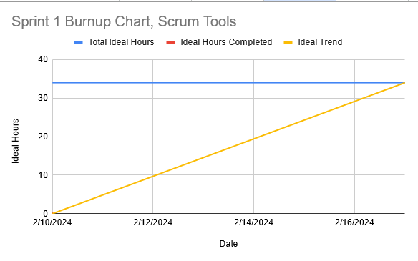

# Initial Scrum Board

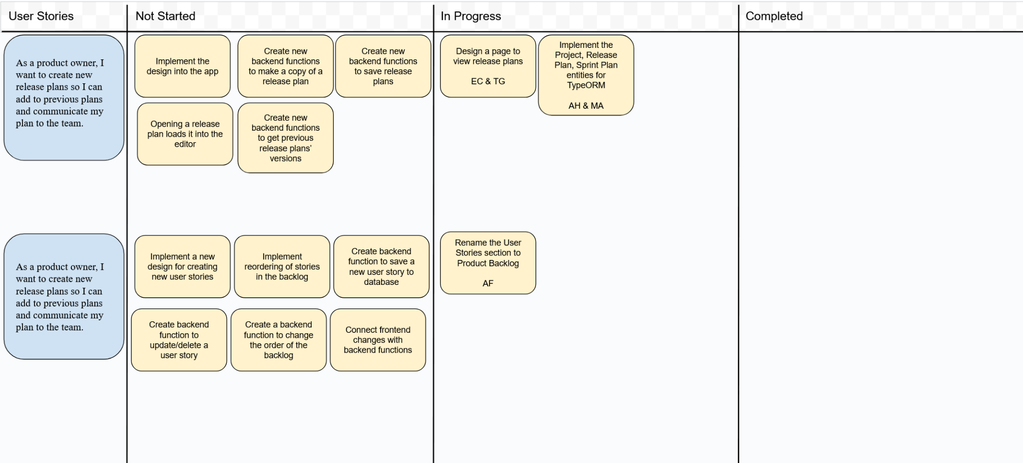

# Team Roles

| **Team member** | **Role(s)** |
| --- | --- |
| Edison | Frontend |
| Tanya | Frontend |
| Arthur | Front/Backend |
| Andrew | Backend |
| Michael | Backend |

# Scrum Times

Monday 1:15-2:00 pm (TA meeting)

Wednesday 1:15 pm

Saturday 1:15 pm